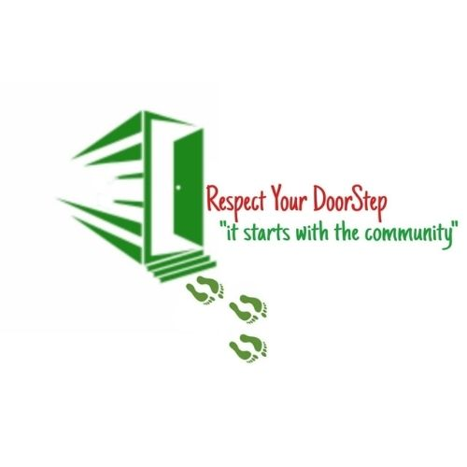

Restoring our living spaces Respecting our doorsteps

**Our Mission:**

Maintain what we reclaim and restore on a level that will make us proud of our living spaces.

* Maintain order and neatness of our area
* Sanitary & hygienic conditions in our area (solve sewer spillages)
* War on leaks
* Repair roads – close potholes
* Eradicate Illegal dumping sites
* Clean & Green open spaces
* Beautification of our living spaces
* Promote township economy by facilitating eco-tourism programs

**WE ARE NOT A REPLACEMENT FOR MUNICIPALITY**

**We are doing general cleanups & beautification with the help of the community**

**This is done voluntarily – with no financial gain**

**While it is the government & municipality’s mandate to ensure that its citizens stay in a clean and safe environment it’s also the responsibility of citizens to maintain clean, healthy living conditions.**

We are of the view that we should take charge of our properties, walkways, streets, public parks, public toilets, our neighborhoods, towns and townships for us to attract tourists and investors into our spaces.

We will archive clean spaces by encouraging communities to become stakeholders in cleaning our environment and combating illegal dumping and grime in our areas, this initiative taken up collectively by the community to make their communal places clean, fix potholes, fix street water leaks, sewer spillages, unmarked road signs, dark streets, moreover is to instill the spirit of community participation and civic pride for their townships, towns, cities and villages.

***Methodology of successfully conducting a community led cleanup campaign***

This campaign began on the 2nd of February 2021, Based on experience gained during implementation of previous cleanup campaigns that we organized and conducted with the community members and local leaders, besides clearing illegal dumpsites the activity was also used to raise awareness on the consequence of irresponsible waste dumping.

**OVERALL THE CAMPAIGN PROVED THAT NOT ONLY DOES THE ACTIVITY SERVE THE PRACTICAL PURPOSE OF CLEANING BUT IT ALSO CREATES A GREATER SENSE OF UNITY AND FRIENDSHIP AMONG COMMUNITY MEMBERS. ADDITIONALLY THE POWER OF BEAUTIFICATION IN A CLEANUP CAMPAIGN WOULD NATURALLY MOTIVATE RESIDENTS TO BELIEVE THAT THEIR PROBLEMS COULD BE SOLVED, RESULTING IN A SHARED RESPONSIBILITY FOR SUSTAINABLE COMMUNITY MANAGEMENT**

**Lessons Learned**.

It has been an uphill battle to successfully implement the clean-up campaign and maintain the momentum.

* Lack of working equipment’s
* Personal Protective Equipment
* Lunch & Refreshments
* Stipend for volunteers (as sometimes we have to work outside our residential areas, they need to bath and wash their clothes)

BUSINESS COMMUNITY

We would like to thank the following business entities for their continuous support since inception of the programme

 

Supporting NGO,S

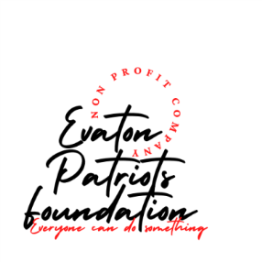

Diphethogo Community Development